**Enable Component Subcomponent Substitution**

|  |  |  |
| --- | --- | --- |
| *a client interacts with both components and subcomponents at the same level of abstraction* |  | *capture the common abstraction with an interface to enable substitution* |

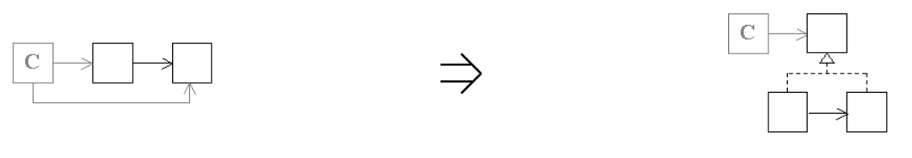

**Context:**

[Enable Component Subcomponent Substitution](https://web.archive.org/web/20090914084948/http:/www.refactoring.be/thumbnails/rtn-ecscs.html) is a key refactoring in [Evolving to the Composite Pattern](https://web.archive.org/web/20090914084948/http:/www.refactoring.be/thumbnails/ec-composite.html)

See also :[Enable Substitution With Interfaces](https://web.archive.org/web/20090914084948/http:/www.refactoring.be/thumbnails/rtn-eswi.html)